Jeffrey Paparoa Holman

1. Chapter Ten from The Lost Pilot: a memoir (due September 2013).
2. PTS/D 101 for Kids – a reflection on post-traumatic stress/disorder in the families of combat veterans.
3. Poem: action stations.
4. A selection of poems, including a draft of Heading for Hibbing, written about a trip to Bob Dylan’s hometown in Minnesota while the author was on the IWP Residency 2012.
4. Blog: < http://paparoa.wordpress.com/ >

[…]

Ch. 10. The Old Illustrians: writing from memory.

My father, Petty Officer W T Holman, Signals Deck, HMS Illustrious, Pacific, 1944-45.

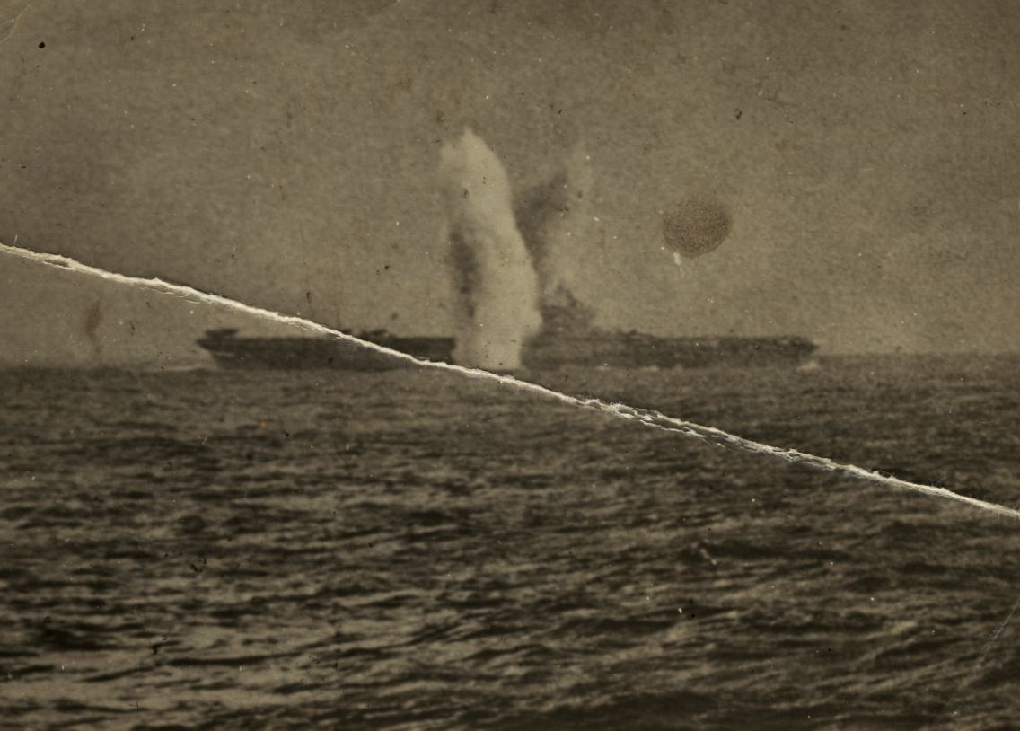
Near-miss: kamikaze strike on HMS Illustrious, Royal Navy aircraft carrier, at 100 miles S-S-W, Sakashima Islands south of Okinawa, 6 April 1945. My father was on the bridge.

“I think we probably wanted to invent him for ourselves. I think I wanted to tell a story, and he was available”.
Daniel Swift.

“The moral backbone of literature is about that whole question of memory…Memory, even if you repress it, will come back at you and it will shape your life. Without memories there wouldn’t be any writing: the specific weight an image or phrase needs to get across to the reader can only come from things remembered – not from yesterday but from long ago”.
W.G. Sebald, the last interview, 24 September 2001.

“ For Sebald everything is an uncanny memento mori: even a photograph is a device through which the dead scrutinise the living”.
Peter J. Conradi.

“How can we enjoy memoirs, believing them to be true, when nothing, as everyone knows, is so unreliable as memory? […] To this extent, memoirs really can claim to be modern novels, all the way down to the presence of an unreliable narrator”.
David Shields.

Landing in Newark at night, met at the airport by my Kiwi and American connections, Jim and Kelly, it was time to ease back and wash away some of emotional toll my journey to Japan had taken on me. I took some days off from writing during my stay with them in New Jersey, before flying to spend time with my daughter’s family in California. Between my long deep sleeps, Jim and I visited the battlefields of the Revolution around the Delaware, as I adjusted to the colours and sounds of big, bold and loud USA after the public and private silences of Japan. Later in San Ramon, I got to play with my mokopuna, chilling out around the family table as my two-year old granddaughter rediscovered me and practiced her frequent temper tantrums. There was time alone too, and time to think.
On a Sunday afternoon there in May, checking out Radio New Zealand’s online podcasts, I found myself listening to Jay Winter of Yale University talking to Chris Laidlaw on the Sunday Programme. His subject was silence and its many forms: as I listened, it began to occur to me that when it came to breaking silences, of opening up a troubling subject from a particular angle, my trip to Japan was a breach of some very long held emotional silences. Silences in fact that we could no longer even recognise, broken into by the light of a torn image that had survived its subject for sixty-six years.
Professor Winter referred to New Zealand’s national silence on Anzac Day 25 April (the day when we remember Gallipoli, along with the Turks who we fought in 1915); and also a different kind of silence too, where Turkey chokes off anything to do with the Armenian genocide that began on the same day in that same year. Here was an example of a great communal silence - a nation forbidden to speak of an event the rest of the world acknowledges – a silence that if broken can land those Turks who do so in prison. A silence too that New Zealanders will not trifle with, to avoid offending our Turkish brothers.
I thought afterwards of how I had broken silences by entering those lives in Japan; a foreign voice come to meet the families and the kamikaze pilots, to speak and to listen. It was not simply that here was a gaijin with an interest in kamikaze (there have been many of them before me, doing such research in Japan), but rather that I was actually family - that I came in my father’s stead. The son of an old enemy appears from nowhere with a picture of what might well be the moment of death for your long lost brother, your uncle – and he wants to meet you. What does he want? Why has he come? What do you say?

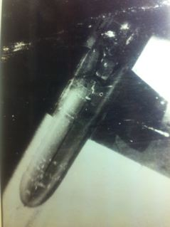
Released: the moment of truth for an “Ohka” piloted rocket, dropped on its one-way mission from a G4N Betty mother ship. Source: Kanoya Peace Museum, Kagoshima.

There were many silences for me in those two encounters: with the Nagata family, when my translator Ritsu was at times so involved in talking to them that I was almost a spectator, yet comfortable being so; in the Nishida household, where Yuka the translator was a family member with limited English. There were inevitable gaps – and peak moments too demanding silence, as when Hideaki the nephew handed me his dead uncle’s samurai sword. I held it with both hands as I knelt, while Yoshiaki Nishida the kamikaze’s younger brother looked mutely on. Anything I might write or say now about that moment of silence is only a shadow of a substance that was there - and has passed. The silences we shared did their work, lost in whatever was said afterwards.
And now of course there is another kind of silence: the present, the issue of all those things having happened, never to recur, existing in the memories of a small number of people each of whom has taken something ineffable into themselves from those intense, emotionally loaded encounters. We may never meet again: how can we know that it happened? That we ever met? Only now by telling stories: “I went to Japan”, “the gaijin came to see us”. Out of the silence of the past forty years and the deep silence of my dead father, his story has begun to speak, summoned from the blurred image of a moment in war – and yet not my father entirely, but all the voices within the picture. What any other person makes of our lives however is surely not us doing the speaking - it is them, their side of the story.
Daniel Swift has written in his memoir, Bomber County: the Lost Airmen of World War Two of his search in Holland’s wartime graveyards for traces of a dead grandfather he never knew, a man who died in June 1943 returning home after a night raid on Munster:
We went to Holland and we didn’t find him exactly. But we were cheating a little, as we already knew where he was buried. I’m not sure that we wanted to find him, in the end; I think we probably wanted to invent him for ourselves. I think I wanted to tell a story, and he was available.
I was never sure quite what I was doing, or what might happen if I went on such a pilgrimage to Japan. I am discovering that memoir is invention, a foggy recall stitched together from the fragments of whatever remains; underneath its ragged clothes burns however fitfully a desire to remember. My father was available, so I set out to tell a dead man’s story. I knew instinctively that if I did not, he would certainly die, die twice over, die so completely he would vanish. As long as I might live, I would have no peace.
This pervasive human instinct to tell stories and to memorialize the dead, until they attain to almost mythic proportions, is what separates us from the animal kingdom. Not only does it mark us as a different order of being, it signifies a spiritual nature than can never be wholly satisfied with, nor fully at home in the material world: “He has also set eternity in the human heart; yet no one can fathom what God has done from beginning to end” (Ecclesiastes 3:11). Breaking such silences - clothing this sublimated desire with names and dates and places and faces – is in its own way a need to partake of the resurrection of the beloved dead before any such grand event takes place. In calling up my father and his former enemies from the grave of forgetfulness, I want to give them back some kind of life, one where mercy triumphs over judgment, as the Good Book says.
I began this process long ago – in poetry I wrote just after my father died – and I don’t think I’ve ever quite stopped. A feeling of being cheated through his many absences, that I took not enough notice of him when I had him near, or even a stubborn resistance to the idea that death could mean oblivion - all of this, perhaps. Father & Son, a poem written in 1973 begins, ‘I do not want another father: old man, now/dead, that cancer faded/and swelled you, speechless/at the door, yellow/feathered fingers’. Twenty years later I was still writing about him, in As Big As A Father: ‘…and death’s head torpedoes/blew out of the water/the skiff of my father’. It would be a fair criticism that I’ve made a lot of mileage from losing him early and if he’d lived longer and well, I wouldn't have so much to say. Possibly: but then, if there hadn’t been World War Two, things would be very different for all of us today. The war was in him - its ghosts are in me, and that I would say is the real subject here, his life choosing me. I’m not saying no.
I turn again to that voyager of memory’s deeps: W. G. Sebald, a German writer who refused to deny Germany and Europe’s postwar darkness, in his fiction and elsewhere. Speaking in a final interview before his tragic and wasteful death in a car crash ten years ago, he discusses the pain of memories shared by “a species in despair”, where those oppressed by mental anguish are consuming mountains of pain killers, the most vulnerable of whom are the wandering, revolving populations of a huge archipelago of mental hospitals. Bleak stuff: unsurprising from one who was born in 1944 into a Germany on the brink of collapse, a world where amidst the rubble heaps of his early childhood, nobody would speak of how those broken buildings came to be there in such a devastated landscape. His soldier father returned from Russian imprisonment in 1947, the year I was born: a stranger who also said nothing of where he had been, a ghost from the vanished Wehrmacht.
A silent father, a silenced recent dictatorship, parents and teachers who had made their accommodations with the Nazi regime and now, suddenly, were expected to become a people without a past, a nation that could only have a future. The result was that for the majority of Germans, there came to be no true present: a radical breach in human time that brought forth a lobotomized Bundesrepublik, where the forgetting and suppression of the Nazi era became a normal mental illness. In many ways, it was the same in Japan post-1945: death or forgetting, as my friend Ken observed when I arrived in Kashii in April. Sebald would make it his life’s work to resist this amnesiac psychosis, first by moving his post-doctoral studies to Manchester in 1966, then in 1970, taking up a post as a lecturer at the University of East Anglia, remaining in England until his death.
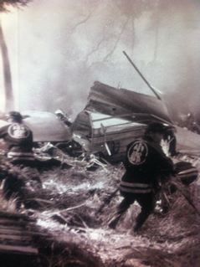
The wreckage of a B-29 bomber shot down over Tachiarai. Source: Peace Museum.

His reflections on a lifetime of dealing with such memories, writing fictions that grapple with the complexity of our relationship to the past, can provide us with clues as to what to do with our own difficulties. There is no real escape, he believed: at the very least, you could subdue painful memories by distractions; his method was to walk his dog, and yet “that doesn’t really get me off the hook. And I have in fact, not a great desire to be let off the hook. I think we have to stay upright through all that, if it’s at all possible”. That hook, the pain of memory – I am saying the same about my father and his war – was his subject, and it became his life. Memory, Sebald believed was inescapable and its nature changed with age: the older we get, the more we do forget, but that “which survives in your mind acquires a very considerable degree of density, a very high degree of specific weight”.
My oldest friend killed himself in July 2007, just before his sixtieth birthday, leaving me holding his ticket to a Bob Dylan concert. He’d been to one other Dylan gig here in 1999, but this was to be a shared event for two lifelong fans. A trained mechanic, he ran a hose linked to the exhaust pipe of another car through the window of his diesel engine vehicle and in the early hours of the morning, sat and waited to die, his mother’s picture clasped to his chest and a Bob Dylan tape playing in the cassette deck. I had known him for almost fifty years and was acutely aware of the psychological scarring in his life as we shared our secrets over the decade leading up to his death.
He was a victim of his father’s wartime post-traumatic stress disorder: savagely beaten as a child by a man who looked like he couldn’t harm a fly. His Dad was subject to uncontrollable rages when the lasting effects of terrible head injuries suffered in the war triggered in him irrational eruptions of anger. A sniper’s bullet had hit him in the face on an invasion beach twenty years earlier, exiting behind his ear, leaving him partially deaf and unbalanced in his emotional life. Like my father, he had missed death by inches and returned to civilian life scarred by incommunicable trauma; like my father, he attacked his son, giving him entirely the wrong message about his place in the universe.
It was those early messages, finally obeyed, that killed Frank; they overcame him as he struggled with the depression their weight of grief had laid upon him. It is of this specific weight that Sebald speaks: unsurprisingly, some of his own characters are suicides, Holocaust survivors who like Primo Levi finally took Hitler’s message to heart, in spite of outliving him and his vile regime. Weighed down with such memories, he concludes, “it’s not unlikely that that they will sink you. Memories of that sort do have a tendency to encumber you emotionally”. For whatever reason – so far – I feel I have been fortunate. Writing does at least give us the power to address such encumbrances and even use them as a way forward. I think this is exactly what I was doing when I started on the trail of my father’s old shipmates in England, back in 1993.
I’d met a former Royal Navy man at the therapeutic community where I was working in rural Kent: Hugh was a Scot on the staff who had warmed to me and we talked a good deal. He discovered I came from a naval family, and hearing of my Dad’s war on Illustrious and his early death, he suggested I place an advertisement in the Old Shipmates Sought column of the UK Navy News – which I gladly did. I had three prompt replies: one from Bill Griffiths in Croydon, who had written a book about service life, My Darling Children: war from the lower deck; another from Bill Weston in Birmingham, an old salt indeed; and the last from Derek Taylor of Colchester, who had actually been trained by my father, when he joined the Illustrious as a young signalman.
I contacted each of them and made plans to visit. Bill Griffiths had been on the carrier, but in another mess: unsurprisingly, in a crew of over 1, 200 men he had never met my father. He was pithy and witty on life aboard ship, telling me of his recent book, “about life below decks, the lot of the ordinary seaman, not the brass hats and admirals”. It is a colourful and authentic account of what it was like to be a sailor during the war, from entry through to discharge; I have used it in the chapter about my father’s first experiences in the Navy. Derek Taylor too was a fount of knowledge, and better still, he knew Dad.

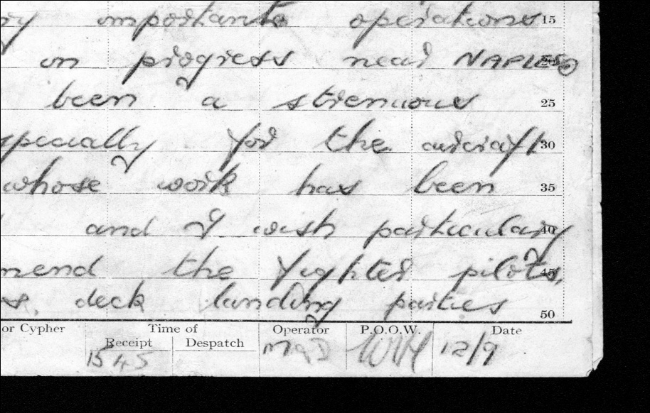
A signal signed off by my father: sent from HMS Illustrious in the Mediterranean, September 1943. “WTH: P.O.O.W” = Petty Officer of Watch. Source: Derek Taylor.

Derek gave me armloads of memorabilia: the carrier’s crest, a painted plywood sailor making the letter “J” (for Jeffrey) with semaphore flags, and an old signal, sent in the Mediterranean in 1943, signed off with those familiar initials, “WTH” – William Thomas Holman. When I say he knew my father, it was from the perspective of a lower rank; his primary relationship to him was to receive his instructions and obey orders. Dad was efficient and very professional, Derek recalled, but there was no expectation of any intimacy that might lead to him having any inside knowledge of my father. In a photocopy of a photograph he made for me of the Signals Mess at Trincomalee, Ceylon in 1944, there they sit; from the third rank down - Bill Weston, my father and Derek - in a vertical line like figures on a totem pole, almost as if posed for my posterity.
It was with the same impulse of vain desire that I travelled to Birmingham in April – after the visits to Bill and Derek – to meet Bill Weston. On the phone he’d said yes indeed, he did remember my father well. He’d be happy to meet me at the Nautical Club and gave me good directions. I boarded a train at Euston station on one on my weekdays off from Waterstones Bookshop and headed north. The account of meeting him that follows was written on the train back to London, and is reprinted here as set down. I don’t want to try and improve on my impressions of what it felt like at the time, nor alter the feeling of the lesson I think it taught me. The dead can be very elusive when they want to be, especially when your spirit guides can only take you as far as the cemetery gate.

Hard to Remember: after Birmingham and Bill Weston.
The train’s jerking to a stop at Birmingham International and I’ve turned off old Bob on my Walkman; with my right ear gummed up, I can’t hear him and anyway, I need to write out what’s going on inside me. A bellyful of steak-and-kidney pie and chips deadens some of my feelings, but here goes with what’s left.
Arriving from London, I walked from New Street station to the Nautical Club in Bishopgate Street, feeling proud I’d spent money on a map and not on a taxi. At least Ive seen a piece of Birmingham close-up, walking under tiled bridges, along streets named Navigation and Holliday. I found the place with the aid of an old salt, steaming in the same direction. I took pictures of the prospect, framed by mines, torpedoes, turreted guns and the obligatory anchor at the door.
A silver-headed man emerged, smiling and waving, hailed me over and shook my hand. He posed for me with the doorman and a cardboard sailor cutout: Bill is much more cheery and loquacious than his telephone persona. We chat and then he has to leave me to go into the “meeting”, a large hall full of aged nauticants at tables around the walls. I guess he’s got business to attend to, so I wait in the foyer, reading notices bewailing rusty submarines of great antiquity needing TLC and a plea for witnesses (or survivors) of a friendly fire accident in 1939! Contact Seadog X at the address below. I’m still stooging about when another snow-topped sea sage approaches and tells me I’m his man, he can tell by the twang. Bill Weston? The same! So who was…? Who knows, who cares?
I mumble, I babble my version of the confusion, but Bill’s not fazed. He’s dapper in the dark blazer, ship’s badge on breast pocket, white shirt, blood red British Legion tie and grey slacks: a civvie in uniform, still serving. He’s outlasted my Dad by twenty years and looks good for another double decade. He has a bullet-hole shaped depression high on the left of his forehead, disguised by rakes of white hair.
We sit in the bar and it goes a bit quiet. Is he uncomfortable? I’d better make the running. I thank him for coming to meet me and disgorge my “wartime” album; Dad’s surviving photographs. The Signals’ Mess at Trinco, 1944. “That’s me, that’s your Dad, that’s A, that’s B…” and the identity parade continues. I show him photos of the great carrier sailing into Sydney, framed by the Coathanger; on patrol in brooding Pacific sunsets and under attack from Kamikazes. Krump! Whoomph! Waterspouts, men blown into pieces, half the pilot’s skull on the flightdeck, one eyeball still attached. He chips in here and there, but not much. I’m doing most of the work and realise that soon, we’ll run out of pictures.
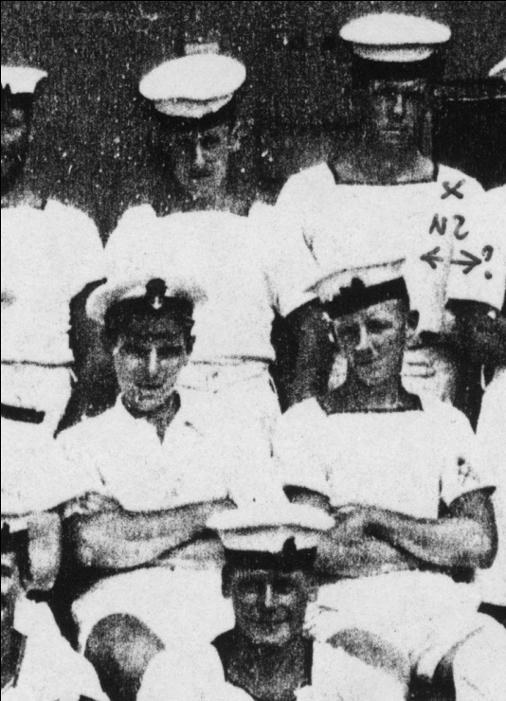
Three in line: Bill Weston (top centre), my father (middle centre) and Derek Taylor (lower centre), signals staff, HMS Illustrious, Trincomalee Ceylon, 1944.

He buys me a Coke and sips a bitter lemon while all around, ageing Jack Tars, encyclopedic ironclads oxidise at anchor, their memories flaking off like rusting boilers, sucking huge pints. He’s driving and has a British Legion meeting at three o’clock. He pulls out three photos from his wallet, one with an illegal white silk scarf draped around his sailor suit; the other has him posing on a rickshaw in Durban, c.1939, flanked by a magnificent Zulu warrior in feather headdress and full regalia.
“Wouldn’t be correct these days, would it?”, he reckons, meaning I guess the flavour of Empire and Noble Savage.
“It’s 50 years, you know,” he reminds me, “a long time ago”. Birmingham vowels, the Brummie inflexions. Well, the photos have all run out and so I have to ask him, “What was my Dad like to work with? How well did you know him?” This is it. “Oh, we went ashore together a few times.” Silence. Please, give me a tidbit, a glimpse of that man I still don’t know. “Can you remember anything about him?”
“Oh well, we were all mates together. You had to be.” Another old salt next door sees the pictures and overhears our chat. He leans over, raises a glass and tells us our reminiscences “get my lamp swinging!” Aye, aye sailor! Sup that froth, sir, as the waves break deep within.
Bill was on the Russian convoys for a while. “The banana boats, the escort carriers”, which makes him a thawed out statistical miracle. If you took a tinfish, the other ships couldn’t stop and you had less than five minutes to live in Arctic waters. We talk a bit about the old Illustrians I’ve contacted: Derek Taylor at Colchester and Bill Griffiths, the ex-secretary of the association, who answered my ad in the Navy News. “Bill’s dead. He died last year of a heart attack.” Another witness gone, another just-in-time visit.
I tell Bill about Dad joining the New Zealand Navy in 1950, working on the Railways, in the State mines, the Forestry and his last role as a cancer patient. I keep wondering why I’m not sat here with my Dad, swapping euphoria in some cosy nautical club - but he’s dead, isn’t he? I begin to want to go now, because Bill won’t, can’t – why should he? – restore that intimacy I’m craving. “Please don’t talk about me when I’m gone, O baby…”.
He talks of his garden, living things in the present tense where God is, as well as “back there” in 1939-40-41-42-43-44-45 in a country never mine. Comes time for Bill to go. Can I get some shots of him now? By the club sign, SNAP, CLICK, over by the anchor, CLACK, CLACK!! I’ll send you one if they’re any good. Thank you for coming. Take care. God bless. I turn away, sure I’ll never see him again.
I walk off down to the lights at Broad Street, heading back another way. I tell myself in words I can’t remember now that nothing can change my father’s death. It’s 22 years now, Jeffrey: let go! Poor Bill. He could only give me that much of himself and leave me to get on with it. Bill Weston? Yes, and Bill Holman, too. Shipmates.
“It’s fifty years, you know. A long time ago. Hard to remember.”

It was difficult re-reading and re-typing this: the vision of a younger self, greedy for an emotional reassurance that was unobtainable; disappointed in some inexpressible way, and yet grateful for what was given. Bill will be ninety now, if he is still with us, and Derek in his late eighties: wonderful, generous men. As I reflect on the mementos they passed on to me, and the memories, I see they have given me far more than I realized. They gave me their time. The visit to Birmingham finally taught me that if the dead were invisible yet somehow with us, then in looking for some traces of my father, I had found the living instead -and it was they who mattered. I have long since lost contact, but all three men are with me still.
Reading this fifteen-year old account, I cannot help seeing similarities with my trip to Japan and the things I experienced there. It’s almost as if the visits and the meetings are seamless, even though far apart in time and my never having planned to seek out the Japanese side of the story. Storytelling: the dead were beyond recall, yet they cried out to me. Not only are we storytelling creatures, we are makers of myth. Måori once knew this and some still do, and we can rediscover it: that ancestors do become mythical creatures once they depart from this material realm. Only story keeps them alive, as alive as we would have them be, to meet our changing times and needs. In attempting to tell my father’s and the pilots’ stories as history, inevitably they have begun to merge into myth – if only because word of mouth and text on the page is not them at all, but always something other, pointing elsewhere. Where to go now with these storied figures is a mystery to me.

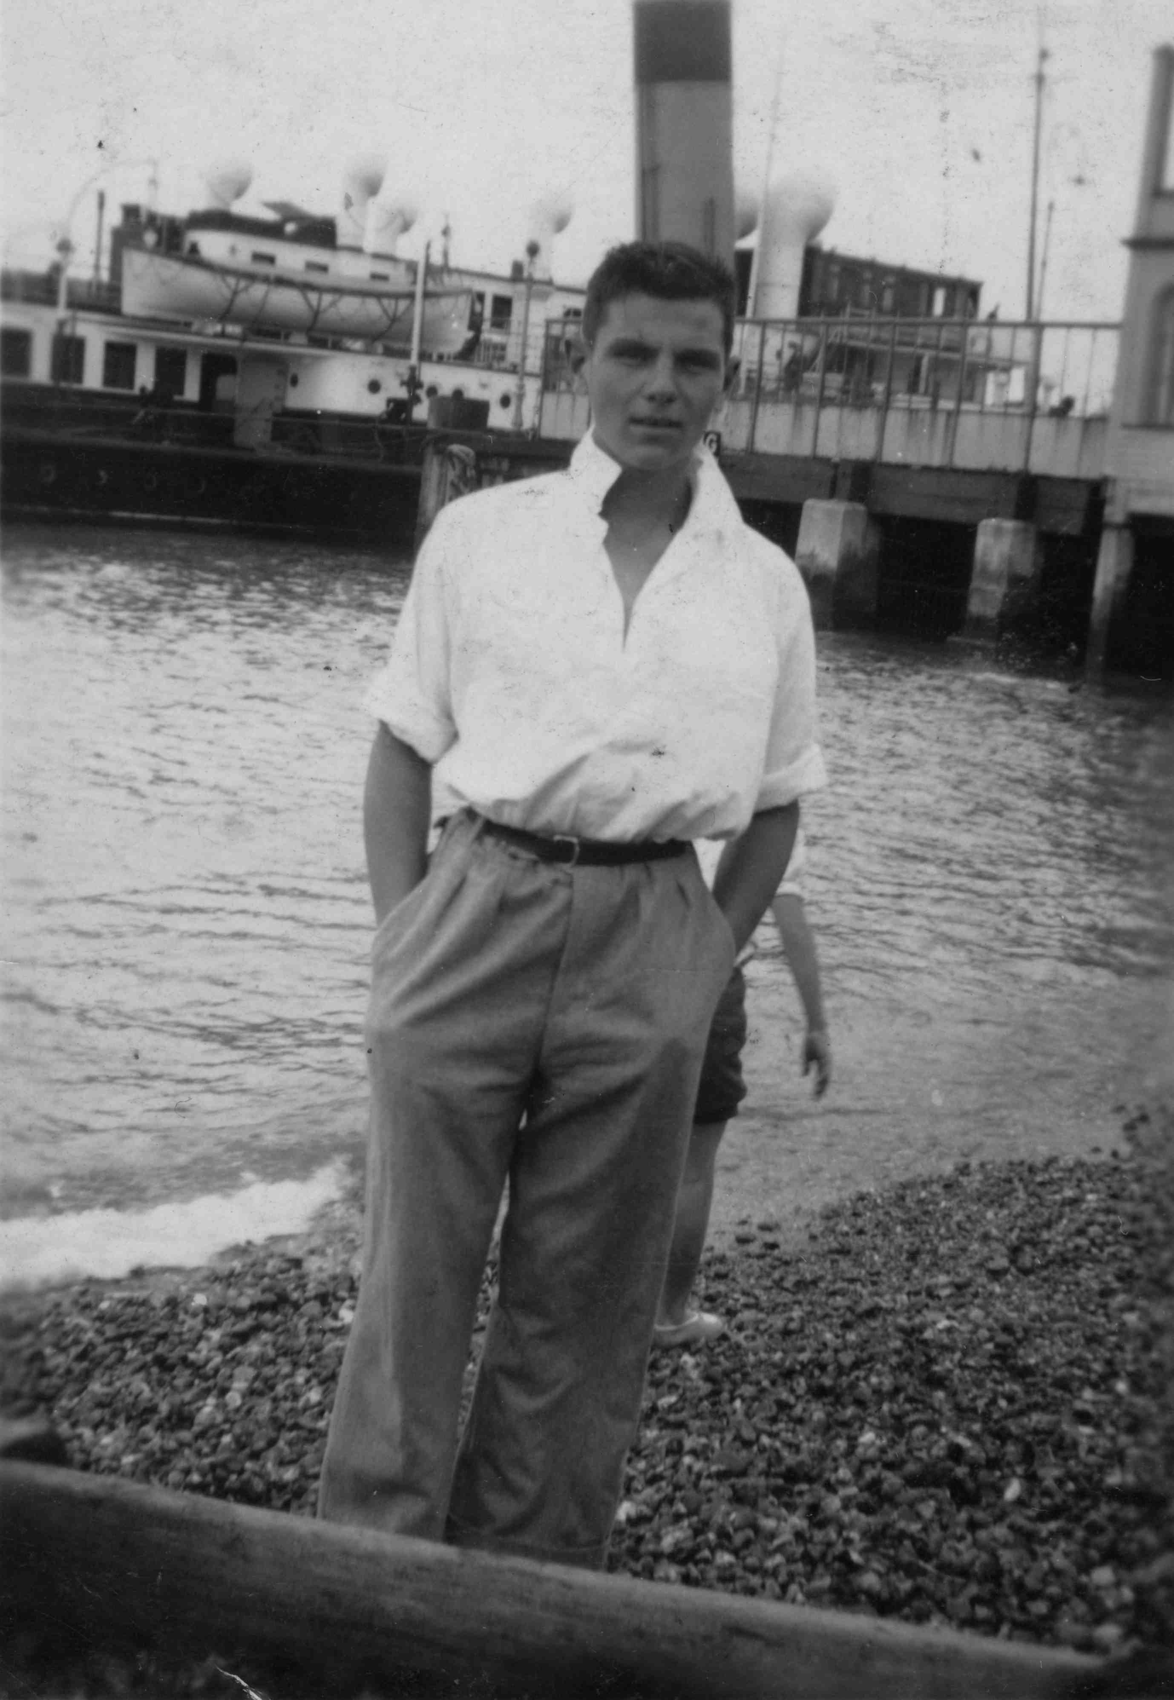
William Thomas Holman: at the seaside as the war clouds gathered.

Early in 2010 when the idea for this book was forming more clearly, I read the text of a lecture given by Dr Jennifer Clement, a colleague in the English Programme of the University of Canterbury. A Renaissance literature scholar, her subject was humility and the use of personification. In the discussion of the figure of humility, she had this to say: “…we turn to the figurative for what can’t be understood, or expressed in the literal, even though we use the literal to express the figurative. We turn to the figurative to encounter, at least within our limits, what is unknown in some way”. She was discussing a George Herbert poem, Humilitie, where that particular quality, personified shows the downside of prideful Vertues, portrayed figuratively in Aesops’ fable fashion as animals.
The lion in the poem is a literal lion indeed, but stands for anger, the turkey for jealousy and the crow for pride, etc. She elaborates her points by referring to a well-known memoir by Norman Maclean, A River Runs Through It - a fictionalized account of his life with his father (made by Robert Redford into the 1992 film of the same name). The narrator responds to his father’s observation that he likes to tell stories. “Yes, I like to tell stories that are true”, he replies. The father responds, “After you have finished your true stories sometime, why don’t you make up a story and the people to go with it? Only then will you understand what happened and why. It is those we live with and love and should know who elude us” (160-1).
Dr Clement comments: “The father ties the imaginative, fictional effort of restoring the dead to understanding and respecting those dead, and through this tie, the distinction between a true story and a made up story blurs. Both are, simply, stories. The dead are both too close, and too distant – too close because they haunt us; too distant because they have left us and, perhaps, because we never really knew them”. Personification, she feels, can “bring the dead into focus…[and] make them legible.”
I responded to her at the time: “Your discussion [from Norman Maclean onwards] on truth and fiction, telling stories and restoring the dead to life lays out, almost perfectly, something I have been trying to articulate to myself, the prospect of writing a memoir”. I go on to talk about making the attempt to write what I am writing now. “The story I am calling The Lost Pilot, and the prospect of this cross-genre monster scares the shit out of me. But time is short and there is not enough life left for more of the little poems that “sit up and beg for their cube of sugar, like little pet dogs” (so said Peter Reading, the English poet, reflecting on his epic poem, Evagatory). It was what you wrote about the dead that stopped me in my tracks…the poetry I have written about my Dad is the story – so far – about a stranger. I have this hunch that the only way to approach his truth now is through a fiction, following known facts”.
What this amounts to is simple, really: unreliable memory and an unreliable narrator, in the sense that if my father were here now, and read this manuscript, he would have to set about correcting me, as much for my attitudes as the parade of facts. Yet even he – a very well read man – would have to admit that writing is writing, it is not the life as lived. This is a true story, made up to fill the inevitable gaps, using both fictional and historical techniques. It doesn't do him justice, nor does it do so for those six Japanese airmen who died that day in 1945. Yet for me it is a kind of love letter to those dead; it doesn’t matter if I’m only talking to myself. It’s payback time and I want to believe that now, I really have paid something to someone else - in their own mysterious currency.
Ah well, in the end perhaps this is what memoir really is: talking to ourselves as night falls in a vast cemetery at the edge of time. And time that is holy, time paying itself out in strands of unutterable loveliness, weaving us all into a story at the heart of the eternal.

Ahakoa ka rere atu, ka rere tonu mai ngā tai o ana moana, kāore te heremana ngaro e kitea. The tides of his oceans will continually come and go, but the vanished sailor is nowhere to be seen.

--------------------------

PTSD 101 for Kids.

“In a combat situation you wake from sleep instantly aware that this could be the last time you awake, simultaneously grateful you’re alive and scared shitless because you are still in the same situation. Most combat veterans keep this awareness – that death is just around the corner.”
& “A large part of treating PTSD is simply getting the veteran to remember and talk about what happened to him. [...] Killing someone will affect you. Part of you will think you’ve done something wrong. It’s drilled into you from babyhood”.
Karl Marlantes, “What It Is Like To Go To War” (Atlantic: 2011), p17.
It became clear to me reading those lines that here was a description of the mental state of my father - one he has transferred to me in my childhood years, through an unstable and unpredictable experience, growing up under the same roof of a man who has had to kill for a living and risk death daily. You experience it as stomach-curdling fear, a hyper-vigilance that demands, once you are awake, that you wake up and get up, get ready – for what? Who knows – you just know it’s time to fight. Or to run.
“Death is just around the corner” – that made so much sense of him, for me; and why death has obsessed me (unfortunately, secondhand, as I have never been in combat). I shared the fallout of his PTS/D with my brother and my sisters – except you don’t know what the hell it is, what made him like that, what kept my mother too in a condition of wariness and reserve, making herself small like a mouse alert for the cat - and my grandmother as well, always talking about bombs and rockets.
I see now that she was probably the healthiest of the three of them, although my mother would also talk about her narrow escapes during the German bombing of Liverpool and the V-weapon attacks on London later in the war. Women are better at this: in my experience they talk more about what matters, not so afraid of appearing vulnerable, weak. Yet who could they talk to in a remote New Zealand mining town, where nobody really wanted to listen to Engish immigrants regaling them with war stories – even had they been willing, and able to tell?
But my father: it was alcohol he medicated himself with, gambling he used to simulate the adrenaline rush of high alert, action stations, and it was violence against his wife and his children that resulted when he flicked off the safety catch - and went back to war. The war did not kill him straight away – it took thirty three more years, from 1939 until 1972 to finish him off at the early age of fifty. Cancer, yes – but it was undiagnosed and untreated combat stress, as much as anything else.
And I wonder why I’m obsessed with war: his war, their war? That’s because he relived his war with me and his other children and it still goes on today. Every time we send men (and now women) to fight in our stead, they come back as if from another world and spend the rest of their lives as aliens and refugees from civilian reality – unless somebody speaks about it. We, their children live this with them – that is why I had to write The Lost Pilot.

action stations
- i.m. CPO Yeoman of Signals W T Holman RN JX157199 1939-45 RNZN 1950-53

knowing always death is here
all your life was action stations
living death was there

gnawing nails and grinding teeth
waiting for the end to come
dying everywhere

wounds you bathed in alcohol
gambling in adrenaline
relived those scenes

even now the war is over
senses stand on high alert
your being hurts

wife and family friends and children
look like them
dead men

all the years for death to come
every hour his breath your breathing
every one

when he came your broken body
lay beside him like a doll
the last patrol

the death you died is always in me
stand me down
on hallowed ground

Sample poems.

Possum (for John Clare).

When morning comes we go and loose the dog:
we walk upon the frost that stings our legs,
our breathing close to snapping in the air,
the barking dog cavorting everywhere.
We plunge into the bush and find the track
that leads into the valley and the traps.
There’s nothing caught until the very last
and there he is, a silver-grey, the frost
all gone from where he’s dragged the trap.
My brother whacks his head with a single thump
and both his eyes bulge out, he jumps and kicks.
The dog goes bonkers, chewing rotten sticks,
he tears the sack we carry, hot for blood.
The possum takes a few more whacks, his head
rolls over, now he’s dead. We yell and jump
like mad, we’re movie Indians counting coup:
two and six for a token. Our hands are freezing
but we take the scalp: Hoka Hey! Yelling
and screaming like a bunch of Apaches
we head back home for a feed of pancakes.

Inferno (Strongman Mine 1967)
When Dave Hibbs said he’d take us down
to Greens Dip, Virgil came as an engineer.
It’s not every day you can find a guide
to show you around a working graveyard.
I didn’t see a single soul in torment
but every creaking roofbeam dripped a cry.
I kept my panic station by pretending hard
my old pretence: I was a man, my death not yet.
He showed us vast theatres of oblong space
like cavities in the dead black teeth of giants.
We heard of rats like terriers and of men
like moles who had to be bred to stand it.
To get to the lip of the tomb, you had to bend
low and crawl to the junction of roof and floor.
A moaning wind as chill as a widow’s keening
sucked the light from chaos with its screaming
Down that slope, in the void, lay miners buried
far from help and the findings of inquiries.
I filled my heart with as many tears as I could
possibly carry and saving them for life, skedaddled.
In the pub in Dunollie, knocking back beer after beer,
celebrating a visit to hell with a man who works there.

Dreaming of Te Rauparaha

I was dreaming of Te Rauparaha:
we were drinking in his favourite bar
in the old Thistle Inn
on the shores of Wellington -
he was knocking back a glass of rum
telling me of Kingdom Come
moko on his nose and chin
on the shores of Wellington -
he said, “e hoa, e te Pākehā –
ki konei Pipitea Pā, the pā
was under where we are!”
He took another slug of rum
and gazed at the sea where danger
comes, where warriors when he was young
would haka, kill and sing their songs.
He stood there in his sailor’s coat
this mighty chief from up the coast
and mists of Kapiti I saw that gathered
in those ancient eyes. “E Pākehā!
He rama mōu, he rama tāku, kei te pai!”
& in that boozy eye I saw the worlds
come swaying where he was, the days
go spinning down to earth, where he lay
beached like a great canoe, a rotting waka
tawhito that took him once where he would go
to kill and conquer, trick and trap, the dreams
beneath his sailor’s cap, the old dried blood
all turned to sand. I was dreaming
of Te Rauparaha, drinking with me
in his favourite bar, the Thistle Inn
in Wellington, where it stands today
and dreams of him.

On looking again into Baxter’s Collected Poems.
(for Roger Steele)

Jim you know the score I’m sure: 4am on the beach
in a dream, it’s dark and he shines a light in your

face, this stranger you still can’t see in the black
that’s as thick and as wild as octopus ink, the arm

on the throat and he says, “Do you cut?” Waking afloat
in the paranoid state of a day before that was honed

in the light, media beat-ups of rugby coaches, rapes by
the line that went unreported – man, you must feel at

home in the clouds, wise as an angel predicting my lines.
Like a drunk to the Bar with a hound on my heels, I sat

on a stool and I opened your book: life jumped out with
a curse on her lips, pursued by death full of glee, like

a fan, high as a kite when the whistle blows and
fifteen men hang their heads over mud. Pages of

anarchy tooled into lines that mimic the heartbeat
pumping the nation: the sound and smell of a priest

caught farting, hearing confession from an alkie
barman and over the radio, racing voices, the saw-tooth

judges who ruled the Fifties. Under the bed the springs
go creaking, a Glenn Colquhuon, a freak in the making

and after the joy or the pain – whatever – the Weetbix
rule at Sanitarium. Poets sprawl on a cracked old breadboard

cut to the quick by the wounds of a friend, and Māori voices
in translation spit on the pages and vanish again. Fuck my days

you sing in praise of the twisted ones with their nerves
of steel, who ride to the factory comatose for another

day at the same old wheel. You prophesy walls that tumble
and fall and still we feel the machinery grinding, mincing

the lame with the halt and the blind, while Zambuks mass
to remove the wounded. Seagulls wheel and crawlers

squeal on mates who struggle to feed the whānau, freighters
leave and the masses heave from sonnet to ode in

epic mode. Meanwhile the teachers talk of strike while nurses
ratchet up their claim, and if to you, it’s all the same, no pain

no gain, or turn it off – Jim, you were grim, but you knew how
to laugh, and if I was still that young romantic crying your loss

back God knows when (if I could be that kid again, chip on
my shoulder, locks of gold), with you and the rest of the restless

nation, I’d do it all again. So I close the book and we walk away,
out over Wellington Harbour, where the Māori Jesus sings.

Orphans.

You go looking in your belongings
for the word.

You stand in the red elevator
and wait.

Surely the answer will come in
late November

the month your mother was meant
to die

and she lived. You kneel beside
your beloved

editor and open your mouth
to receive

the host. It is always this
way in

the country of the poem. When
you know where

you are going of course you
are still

completely lost. Look for the colour
of empathy last

seen in December, the month your
father said he would

be there, fell in his kitchen beneath
the waves

of an unexpected stroke. Every
word now’s

an orphan. Every breath is
January.

Memoir (for W.G. Sebald).

The past returns as an iron kettle.
Militant statues stare right back.

If only the leaves could tell the whole story, before
they fall and strip the naked branches speechless.

Europe is a cold cauldron.
Grandfathers laid down their scythes
and shipped their horses to Mesopotamia.

Years passed: all that is left now, a
palm crested buckle, embossed
Baghdad, 1919.

There is a fly sidling over
the regimental history, rubbing
its paws.

It knows the truth, it is the truth, but
one good swipe from a whisk
will kill it.

Memoir II.

Preparing for death is a wicker basket.
Elderly women know the road.

One grandmother worked in munitions, brown
bonnet, red stripe rampant. The other, a washerwoman:
letters from the Front would surface, tattered.

You must take the journey, ready or not.
The old, old stream of refugees: prams
of books and carts with parrots.

Meanwhile the speeches, speeches: interminable.
When the blood in your ears has time to dry: silence.

The angel will tie a golden ribbon to the basket’s rim.
You will disappear, then reappear, quite weightless.

The birds of Pittsburgh

the female Downy woodpecker scours
an oak not until spooked will she leave
that tree fall is coming and the heat will die

somewhere deep in Philadelphia around the turn
of the twentieth century grandmother pregnant
sent from Liverpool left a newborn son behind

many important unknown events attach themselves
to every family every creature when autumn
darkens prepares and stores some even die

then with luck the revelation the letter that proves
she survived the winter the feather that drifts to the world
below from a bird unseen in the topmost branches

sometimes a word alone will do it a trigger releasing
forgotten stories carried from there in Eau de Cologne
on the scent of betrayals conceived in Dresden

whether or not we choose to like it seasons change colour
and bite the heel I fell beneath the spell of Jack Gilbert
in the age of steel on a ribbon of fire

Heading for Hibbing. (in progress)

Searching.

Google it: they say the Super 8 sucks at Hibbing, smells
of smoke. Won’t stay there. Grand Rapids gets better press
an hour away south. Toyota Yaris at twenty bucks a day, nine
long hours from Iowa City. Mesabi Range: iron ore destiny.

Booking.

The hole in the doughnut is just that: pilgrims know
unless they’re stupid how the journey ends within.
The woman at Enterprise Rent-a-Car has said
goodbye to many - and almost all came back.

Going.

The road is longer than long, fat grain silos
erect as missiles. So many false exits, wayside
demons, there are house high killer trucks.
A map of Minneapolis roads is an octopus just waiting.
Zimmerman.

Out of Elk River on Highway 169, the sky thickens
up at Zimmerman. Coffee, ham roll, a flapping Stars
and Stripes and the time it takes to Grand Rapids.
Gas station blond at Princeton loves my accent.

Marathon Gas Station, Princeton.

She wants to go to New Zealand, “Hibbing? But there’s
nothing there!”. She wants to go to where I’m from, they all
do, all these American want our beauty. I say go, “you should”.
Never knew where Dylan came from - now she does.

Mille Lacs.

Long slow bend, I’m nursing sixty, the world just rips
in half. Mille Lacs: water as flat as the eye can bear meets
sky, meets air, a blue that leaps without perspective, seas of
space stretch out to nowhere and throw the world aside.

Snow.

This is an Indian Reservation: neon casino in the lowering
dark lumbers, shining, void of reason, buff male strippers
on the welcome signs. Tick tick tick, it ain’t just rain: coming
at me horizontal, without a warning the night sends snow.
Grand Rapids.

All that’s visible are his taillights - man behind me, same idea.
Thirty minutes blind in convoy praying hard to see the road.
Every set of lights oncoming hurts the eyes and counsels patience.
“Super 8 Ahead Four Minutes” - lonesome traveller, welcome sign.

Super 8 Moose.

There’s a moose doll in boots and check shirt in the lobby.
Jan my host is a mine of story: “Somebody put a hat on him.
Guy it belonged to he never noticed, couldn't see it on the moose”.
Shows me the picture on her cellphone: there it is, right there.

Breakfast.

They feed loggers, don’t they? Best food you’re gonna find
in a Super 8 - period. Franchise wants the menu altered, way
too good for a budget chain. “We give our boys biscuits and
gravy. Hell no, we won’t change – we’d sooner walk away!”

Mesabi Country.

Those hills aren’t real hills, they’re human hills, they’re iron.
Out of rusty rocks on the roadside, straggles of trees strike
up again; they look pretty sick but they won’t take man for
an answer, say “don’t leave your leftover junk on our land”.
Calumet.

Every building seems abandoned, all the stores closed down.
Carefree Motors is care free now; a sign on the ground says
Rummage Sale. Even the ghosts have got bored and moved
on; only so much a ghost can do when all you miners are gone.

Keewatin: Home of US Steel.

“Mining supports us. We support mining”. So the lawn signs
say. Old men walk the empty streets past Hanna Company
Ore Train 304 , sad as rust in a deserted park. She helped haul
40 millions tons of ore, ‘28 to ’66 - and now she’s just cold.

Entering Hibbing.

See the cemetery first: is Abraham Zimmerman lying down there?
Find the singer’s Hibbing High School: a temple of brick that would
grace anywhere: “the richest gem in Minnesota’s education crown”.
I walk through the doors where Dylan walked to blow his tiny mind.
Hibbing High.

Five minute’s walk from the Zimmerman home, into the arms
of B.J Rolfzen, local legend, literature teacher who sat them down
and opened Shakespeare. His drill struck English in a mining town
where teenage Bobby in the front row sat, sucking every living word.
Ore.

What’s a story after all when iron starts talking?
They moved the whole friggin town four miles north.
You try sleeping on top of something that big.
Half a line of yesterday hums inside you, so you sing.

Iron Grand Canyon.

Horizon to horizon there’s the mine: man-made canyon
of the richest ore, you keep on digging, down and down
and down into the red rust skin, a millions tons and a million
more, where man is an ant swarming on the molten core.

Voices.

In the cradle, Yiddish crooning,
in the synagogue, the cantor’s call,
on the radio, that Race Music and in
your room, the north wind howls.

Cicada.

Deep inside the golden chrysalis all the sleeping forces form
a clumsy mystery soon to clamber out from its casing, to a rough
warm wall. The softness of your wings is gone, the howl of the road
overtakes your soul with its cossack sword and its edible scroll.
Robert Alan Zimmerman
Hibbing Minnesota
Bob Dylan
Highway 61

© All material copyright Jeffrey Paparoa Holman 2012.

